DBS LAB 4:
24k-0810
Problem 1: Arithmetic Operators. Given: A table Student with columns:
- student_id – Unique ID of the student
- name – Name of the student
- marks – Marks obtained
- bonus_marks – Bonus marks
- dob – Date of birth
Tasks:
- Write a query to display marks increased by 10 for all students as updated_marks.
- Write a query to calculate total marks by adding marks and bonus_marks.
- Write a query to find the difference between marks and bonus_marks.
- Write a query to multiply marks by 2 and display as double_marks.
- Write a query to find the remainder when marks is divided by 7.
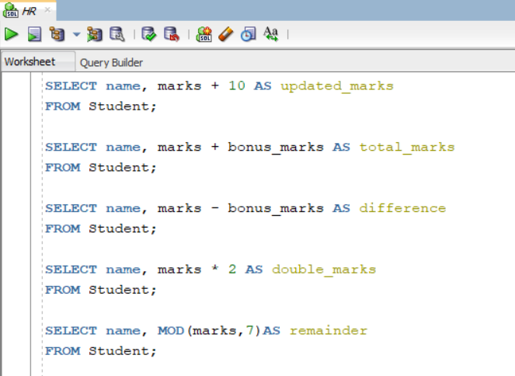
Problem 2: Logical Operators
Given: A table Employees with columns:
- emp_id – Employee ID
- first_name – Employee first name
- last_name – Employee last name
- salary – Employee salary
- department_id – Department ID
Tasks:
- Retrieve all employees whose salary is greater than 50,000 and department_id = 10.
- Retrieve all employees whose department_id = 20 or salary is greater than 70,000.
- Display all employees whose salary is not greater than 60,000.
- Find employees whose emp_id is between 100 and 200.
- List employees whose first name starts with the letter ‘A’.
- Display employees whose department_id is either 10, 20, or 30.
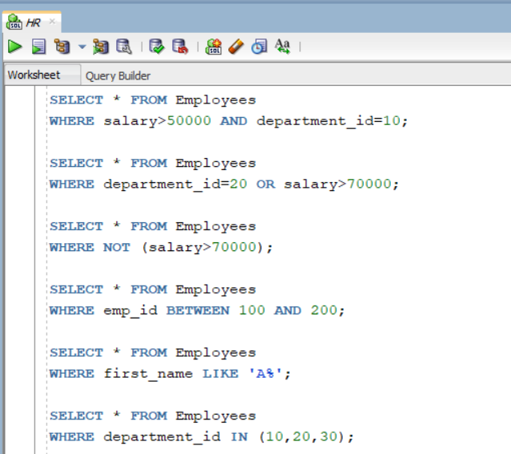
Problem 3: Operator Precedence
Given: Use the same Employees table as above. Tasks:
- Evaluate and explain the output of the query:
SELECT * FROM Employees WHERE salary + 5000 > 60000 AND department_id = 10 OR department_id = 20;
ANSWER: AND has higher precedence than or therefore, employees in department 20 are included regardless of salary
Rewrite the query using parentheses to change the order of evaluation and explain the new result.
SELECT * FROM Employees WHERE salary + 5000 > 60000 AND (department_id = 10 OR department_id = 20);
NOW, it only includes employees whose salary + 5000 > 60000 AND who are in dept 10 or 20.
Problem 4: DISTINCT, Aliases, and ORDER BY
Given: A table Products with columns:
- prod_id – Product ID
- prod_name – Product name
- category – Product category
- price – Product price
Tasks:
- Write a query to list all distinct product categories.
- Display product names and prices using the alias Product_Price.
- Display all products sorted by price in descending order.
- Display the top 5 most expensive products.
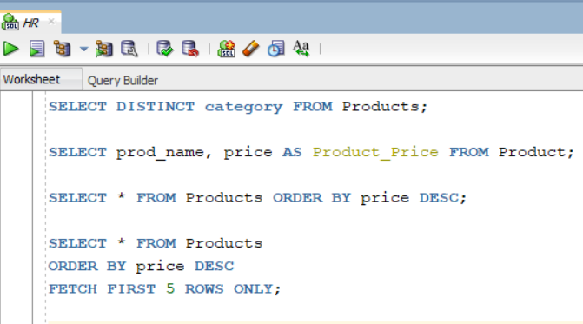
Problem 5: Character Functions
Given: A table Customers with columns:
- cust_id – Customer ID
- cust_name – Customer name
- city – Customer city
Tasks:
- Convert all customer names to uppercase.
- Convert all customer names to lowercase.
- Remove leading and trailing spaces from customer names.
- Concatenate cust_name and city into one column.
- Find the length of each customer name.
- Replace the substring ‘Inc’ with ‘Ltd’ in customer names.
- Extract the first 3 characters of each customer name.
- Find the position of the letter ‘a’ in cust_name.
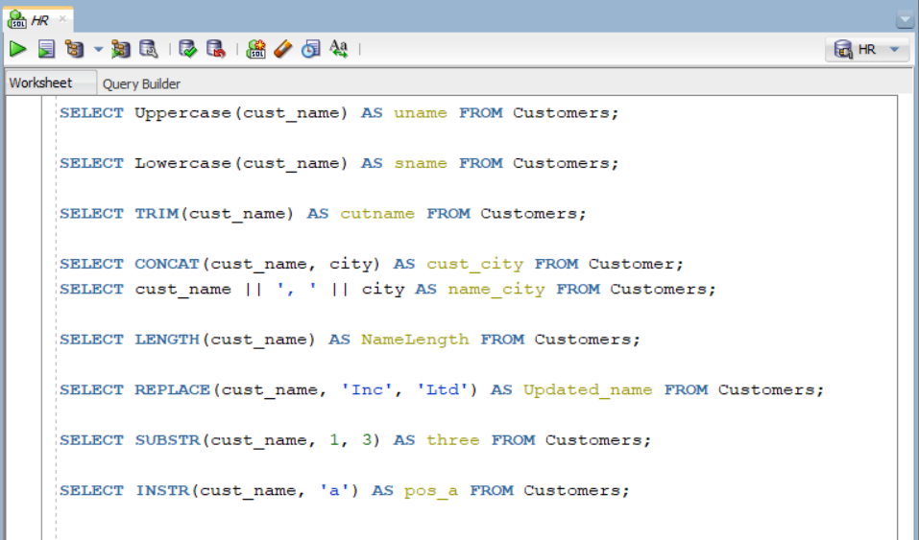

Problem 6: Numeric Functions
Given: A table Orders with columns:
- order_id – Order ID
- quantity – Quantity ordered
- price – Price of the order
Tasks:
- Find the remainder when quantity is divided by 5.
- Round price to 2 decimal places.
- Truncate price to 1 decimal place.
- Find the ceiling value of price.
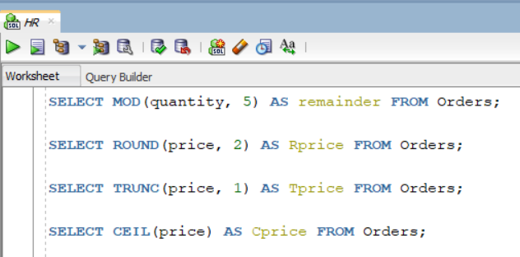
Problem 7: Date Functions
Given: A table Employees with column:
- join_date – Joining date of the employee
- employee_name – Name of the employee
Tasks:
- Find the number of days between 2026–02–10 and join_date.
- Add 15 days to each employee’s join_date.
- Add 3 months to each employee’s join_date.
- Display the current date and time.
- Extract day, month, and year from join_date.
- Truncate join_date to remove the time portion.
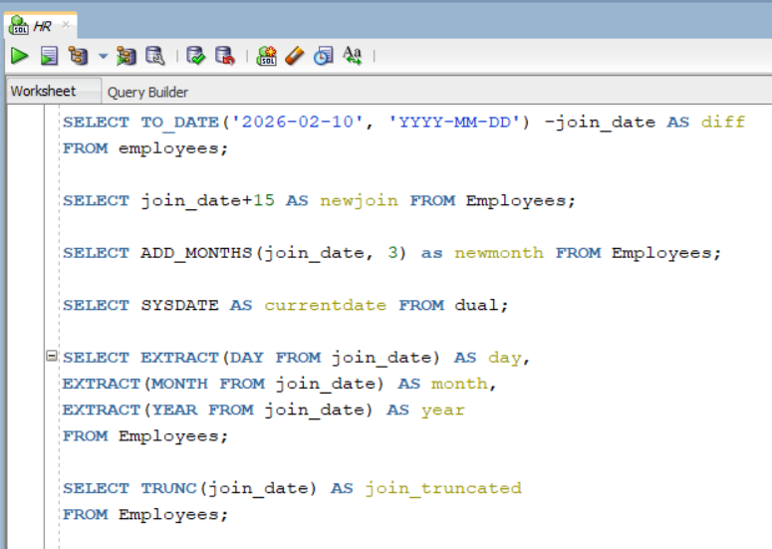

Problem 8: Conversion and General Functions
Given: Any table with numeric or string columns, for example: Demo table.
Tasks:
- Convert the string ‘2500’ to an integer using CAST().
- Format the number 12345.678 as ‘9,999.99’ using TO_CHAR().
- Compare two values and return NULL if they are equal using NULLIF().
- Return the first non-NULL value from a list using COALESCE().
- Replace NULL values with 100 using NVL().
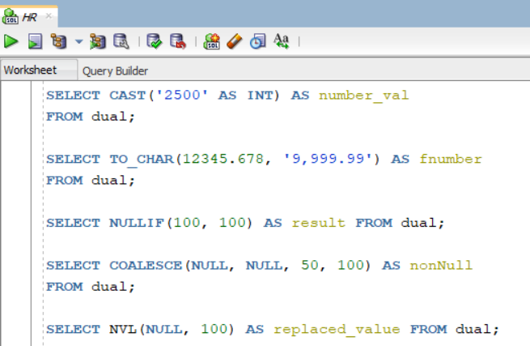
Problem 9: Combined Challenge
Given: A table Employees with columns:
- emp_id – Employee ID
- first_name – Employee first name
- last_name – Employee last name
- salary – Employee salary
- department_id – Department ID
- join_date – Joining date
Tasks:
- Display employee names in uppercase whose salary + 5000 > 70000 and who joined after 2020–01–01.
- Display employee names, salary, and department_id for employees whose names start with ‘J’ or ‘A’, ordered by salary descending.
- Retrieve the top 3 employees with the highest salary, showing names in lowercase and joining dates formatted as ‘DD-MON-YYYY’.
